- Create a comparison table listing the main differences between DDR3, DDR4, and DDR5 RAM, including speed, voltage, and typical use cases.
Answer:
Feature | DDR3 | DDR4 | DDR5
Data Transfer Speed | 800-2133 MT/s | 1600–3200 MT/s | 4800–8800+ MT/s
Operating Voltage | 1.5 V (Typically) | 1.2 V | 1.1V
Performance | Low by modern standards | Good for everyday computing | Higher bandwidth for demanding tasks
Power Efficiency | Lowest of the three | Better than DDR3 | Better voltage efficiency
Common capacity per module | Commonly 2-8 GB | Commonly 4-32 GB | Commonly 8–64 GB or more
Typical use cases | Older desktop PCs and laptops | Everyday PCs, office work, and older gaming systems | Modern gaming PCs, high-performance computers, and demanding workloads
Compatibility | Requires a DDR3-compatible motherboard | Requires a DDR4-compatible motherboard | Requires a DDR5-compatible motherboard

- Open your laptop or desktop (with power disconnected), locate the RAM slots, and take a clear photo of the installed RAM module. Reinstall the RAM module and verify that your system boots up successfully. Refer to your device manual or a trusted YouTube guide if unsure about RAM removal and installation steps.
Answer:
Step 1: Switch off the computer:
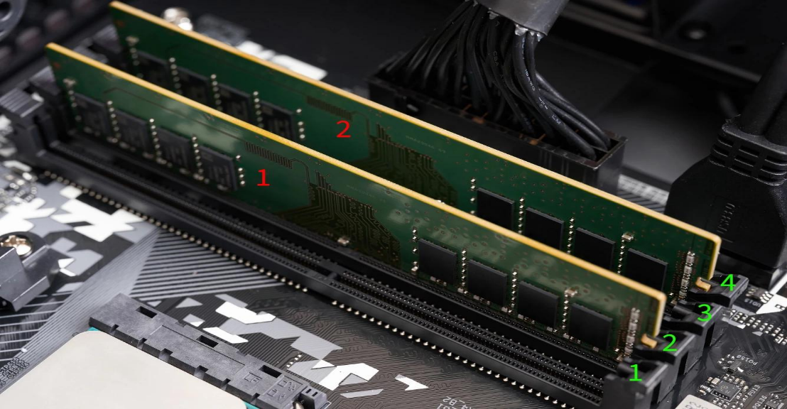
Shut down the computer, unplug the power cable, and disconnect peripherals. For a laptop, follow the manufacturer's service manual; disconnect the battery where instructed.
.

Step 2: Locate the RAM:
Open the case or approved access panel. Find the long RAM slots near the CPU.
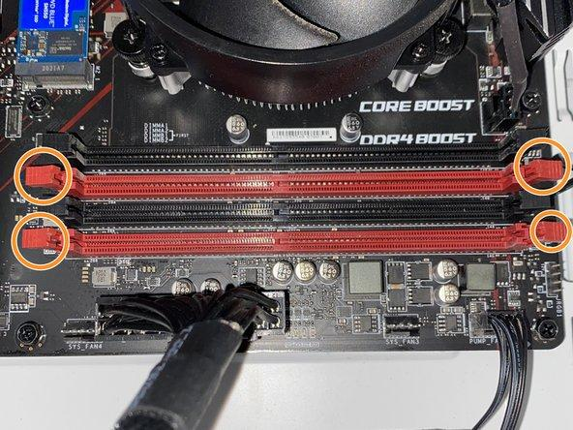
Touch an unpainted metal part of the chassis to reduce static electricity risk.

Step 3: Remove and reinstall the RAM:
Release the retaining clips as appropriate, remove the module by its edges, align its notch with the slot, and press evenly until it is securely seated. Never force it.
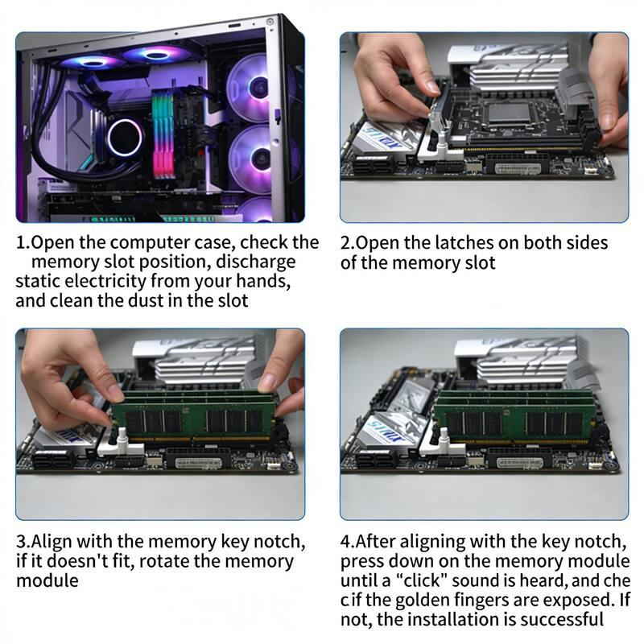

Step 4: Verify boot:
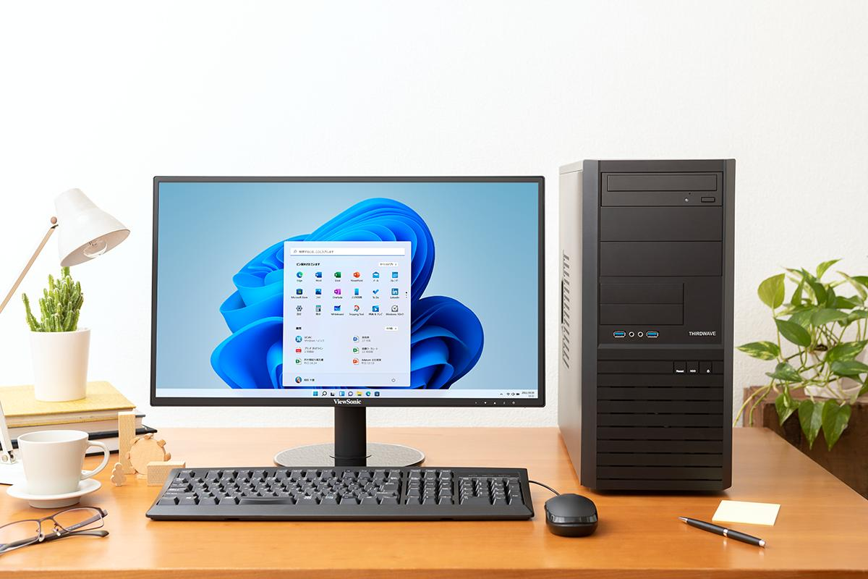
Reassemble the computer, reconnect the power, and turn it on. Confirm that the operating system loads and the installed memory is detected.

- List three key differences between HDD, SSD, and NVMe storage types, and for each, name one app or use case (from apps you use daily) that would benefit most from that storage type.
Answer:
Feature | HDD | SSD (SATA) | NVMe SSD
Speed | Slow | Fast | Very Fast
Technology | Uses spinning  magnetic disks | Uses flash memory with a SATA connection | Uses flash memory with the PCIe interface
Cost and capacity | Usually cheapest per GB; good for large storage | Moderate cost; balanced speed and capacity | Often costs more for high-capacity models; offers very high performance
Best app or use case | Storing photos, videos, and backups | Opening Microsoft Word or browsing the web | Loading games, launching heavy applications, and video editing

Examples of daily use:-
• HDD: Best for storing large collections of photos, movies, and documents at a low cost.
• SSD: Helps Windows start quickly and makes everyday apps such as Microsoft Word and Google Chrome more responsive.
• NVMe SSD: Benefits demanding tasks such as launching large games, transferring large files, and editing high-resolution videos.

- Remove the storage drive (HDD or SSD) from your system, take a photo of the connector type (SATA, M.2, or NVMe), and reinstall the drive. Confirm that your device recognizes the storage after reassembly. Constraint: Only perform this task if you have access to a device you are allowed to open. If not, find and share a YouTube video link showing the process for your laptop/PC model.
Answer:
Step 1: Identify the connector:
1. SATA HDD or SSD
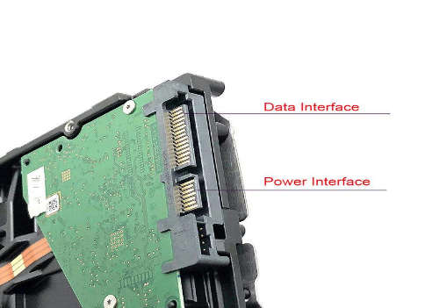
Uses separate SATA data and power connectors in most desktop installations. Common in desktop PCs and laptops.
2.5-inch SATA SSD
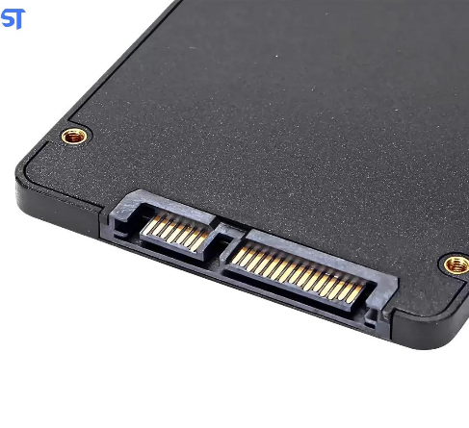
A flash-memory drive with the same general SATA data and power connector arrangement as a 2.5-inch HDD.

M.2 NVMe SSD
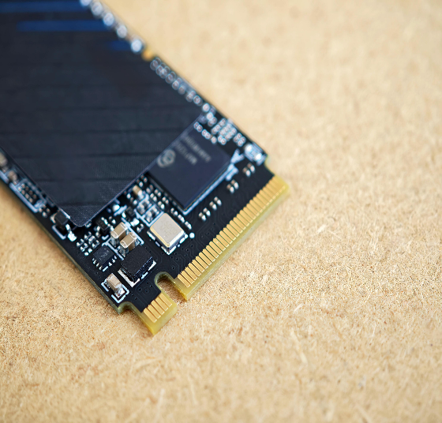
A slim circuit-board drive that fits into an M.2 slot. NVMe is its storage protocol; M.2 is the physical form factor. Not all M.2 drives use NVMe.

Step 2: Remove and reinstall the drive safely:
- Shut down the computer completely and unplug the power cable.
- For a laptop, follow the manufacturer's service manual and disconnect the battery as instructed.
- Open the case or service panel only if you are authorized to do so.
- Locate the storage drive and take a clear photo of its connector before removing it.
- Carefully remove the drive according to the manufacturer's instructions. Avoid touching exposed contacts or forcing connectors.
- Reinstall the drive securely and reassemble the device before reconnecting power.

Step 3: Verify the storage drive:
After reassembly, turn on the computer and check whether it starts normally. In Windows 11, you can also:
- Open Settings → System → Storage to check available storage.
- Right-click Start and select Disk Management to see whether the drive is detected. Do not initialize or format a drive if it contains data you need.

Step 4: If you cannot open your device:
Use a trusted YouTube guide that matches your exact laptop or desktop model.

